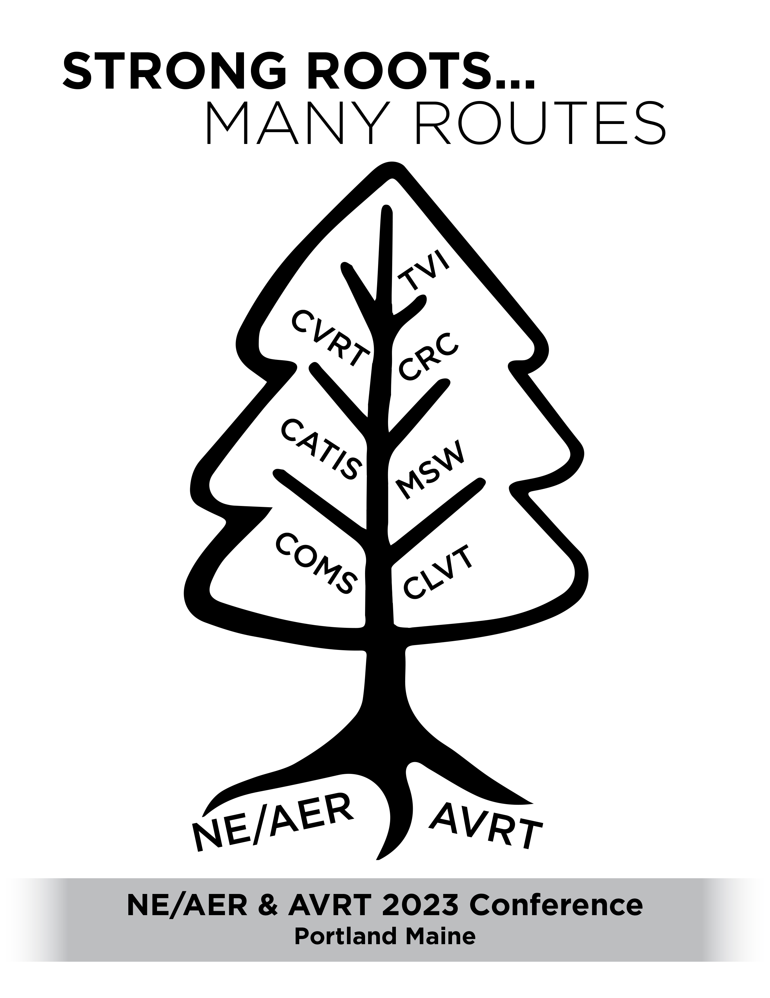
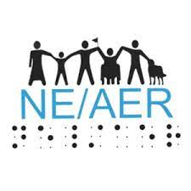
Conference logo of a tree with NE/AER and AVRT along the roots of the tree. The branches of the tree each have a discipline on them (COMS, CVRT, CLVT, CVRT, MSW, CATIS, CRC, TVI).
NE/AER logo of with shadows of people, some with guide dog or wheel chair, holding hands with NE/AER in Braille below them.
AVRT logo of 4 interlocking puzzle pieces

Strong Roots…Many Routes

Joint AVRT & NE/AER Annual Conference

Portland, Maine

November 1-3, 2023

Our Conferences always strive to provide exemplary professional development to all branches of our fields, and this year is no different. This year’s theme, “Strong Roots…Many Routes”, is the acknowledgment that with our strong professional foundations, we are all able to help our clients reach their ultimate goals even if we are coming from different directions. Ideally, we are seeking to hold sessions in the track areas: education, rehabilitation, technology, orientation & mobility, guide dogs, employment, and research. Consider topics such as assessment, teaching methods, transition, self-determination, and collaboration. This year’s conference will reach out beyond our current limits and take our services to new heights!
We invite you to submit session proposals for breakout sessions or a poster session. Proposals should have a practical focus and may address a specific area of rehabilitation practices or principles. Sessions can be 60 minutes or 90 minutes in length. The conference will be designed to encourage participants to expand upon their techniques and resources.

Please consider submitting a proposal using the following form. Additional information can be found at:
- www.nercve.org/ne/aer
- www.avrt.org
- Contacting us at confprogram@neaerbvi.org
- Contact conference program chairpersons directly

Conference Program Chairs,

Judi Lambert Linda Fugate
confprogram@neaerbvi.org avrtconference2021@gmail.com
NE/AER AVRT

Call for Presentations

Deadline for submissions: May 15, 2023

Name of Lead Presenter:
Agency Affiliation:
Address:

Phone number:
Email:
☐ Check here if you DO NOT want your contact information listed in the program.

Co-presenter(s) (name, affiliation, email):

Presenter name(s) as it should appear on the nametag:

Title of Presentation (as it should appear in the Conference Program):

Track:
☐ Education
☐ Rehabilitation
☐ Technology
☐ Orientation & Mobility
☐ Guide Dog
☐ Employment
☐ Research

Type of presentation:
☐ Lecture
☐ Panel
☐ Workshop (interactive)
☐ Poster Session

Preferred Length of Presentation:
☐ 60 minutes
☐ 90 minutes
☐ N/A (poster session)

Who will benefit from your session?

Brief program description (as it should appear in the program - Limit to 50 words)

  - Session Objective:
At the end of this session, participants will be able to (this will be used for CEU credits):

Brief Biographical Information (to be read at the beginning of your session):

Each room will be equipped with a projector and screen. Presenters are responsible for bringing a laptop or any other necessary equipment. Please note any other technology you will need:

Submit proposals electronically via e-mail to confprogram@neaerbvi.org NO LATER than May 15, 2023

Presenters not attending the Conference do not need to register.

